Assymetric Lead-Lag Controller

Owen Lu

Electroimpact Inc.

owenl@electroimpact.com

*Abstract*—Previously, a filtered proportional controller was developed to smooth and lower peak torque requirements of servo-creel motors during add and cut events on the H16 AFP heads. Although peak torque has been shown to be reduced, backer winding issues have been observed when using this identical control structure on the OH20 heads. It is hypothesized that higher magnitude deceleration occurring during cut events will remedy the issue. This paper aims to guide the development of a such a control structure using pure feedback.

# Introduction

The leading hypothesis is that during add events, the carbon is pulled by the feed motor and accelerates rapidly creating slip between the tow and the backer film. This relative motion would imply that backer does not leave the cassette at the same rate as the tow, eventually leading to build up and failures over time. A proposed fix for this mode of failure is to decelerate at a greater rate, using the inertia of the backing tape up spool advantageously to wind the backer. Several options had been proposed in order to achieve this effect, such as increasing gain and reducing set point during operation. However, adding derivative gain combined with saturation seems to be the best option from an implementation point of view as no time critical communication is necessary.

# Initial Control Structure

Initially, a controlled dubbed the “Filtered proportional controller” is used as shown in Eq. 1. The controller converts dancer error signal into a surface velocity command.

|  |  |  |
| --- | --- | --- |
|  | $$C=\frac{K_{p}}{τs+1}$$ | (1) |

During add/cut events rapid tow acceleration is present, which in turn causes rapid dancer velocity changes. The core idea is to have derivative responses in the short term only during deceleration. Thus, we can add another term to the controller $C$ called $C_{d}$.

|  |  |  |
| --- | --- | --- |
|  | $$C_{d}=\frac{K_{d}s}{τs+1}$$ | (2) |

Notably, adding controllers $C$ and $C_{D}$ creates a standard lead-lag controller.

$$C_{l}=C+C_{d}=\frac{K_{p}+K_{d}s}{τs+1}$$

The controller $C_{l}$ can be rewritten in a more standard form shown in Eq. 3.

|  |  |  |
| --- | --- | --- |
|  | $$C_{l}=\frac{K_{p}\left(\frac{K_{d}}{K_{p}}s+1\right)}{τs+1}$$ | (3) |

# Qualitative Analysis

A useful substitution for $K_{d}$ rewrites it as a scale factor of $K_{p}τ$.

|  |  |  |
| --- | --- | --- |
|  | $$K_{d}={γK}_{p}τ$$ | (4) |

This allows us to easily select the transition point for the lead lag controller.

|  |  |  |
| --- | --- | --- |
|  | $$\frac{K_{p}\left(γτs+1\right)}{τs+1}$$ | (5) |

Notably, if $γ=1$ then the system simply becomes a proportional controller, thus, giving the simplest alternative calculation to adding derivative response to increase torque. It is extremely simple, as no derivatives actually need to be taken in the implementation.

The overall effect of increasing $γ$ is to decrease the transition frequency of the derivative controller. This means that a wider range of high frequencies will be amplified (which is akin to raising derivative gain seen in Eq. 4). It is recommended that $γ≤1$ for a standard lead-lag compensator. This is basically the same as amplifying frequencies above the bandwidth of the filter. It is important to note that the steady-state gain has not changed, therefore all dancer steady-state positions are unchanged.

# Saturation and Switching

Notably, the issue of backer unwinding is likely due to the acceleration of the spool and backer film. Delivering the torque using a more smoothed response during an add event reduces the likelihood of slipping. On the opposite end of the tow, a cut event occurs which this controller attempts to use to create slip in the opposite direction, effectively winding the backer. Thus, we only perform this controller switch during negative dancer derivatives.

One implementation is then summarized below for $γ=1$

$$C=\left\{\begin{aligned}\frac{K_{p}}{τs+1},\frac{dx_{d}}{dt}>0 \\ K_{p}\end{aligned}\right.$$

# Simulation

From simulation, the tow acceleration, tow velocity and dancer displacement are graphed and shown in Figure 1. The acceleration, is sharp only on the deceleration but smoothed on the positive acceleration.

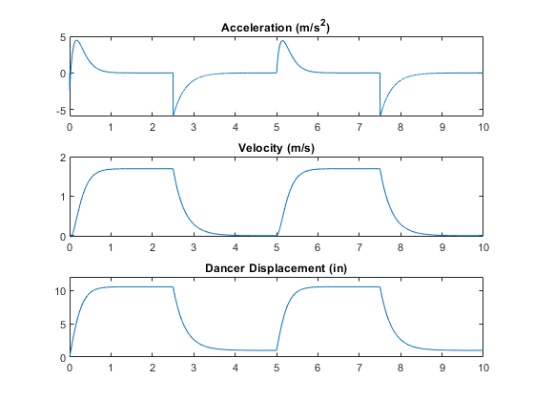

Figure - Simulation of system performance of the asymmetric lead-lag controller

# Conclusion

It has been shown that developing a controller that aggressively decelerates the creel relative to forward acceleration can be created without feed-forward or real-time parameter modification. Using the simplest proportional controller implementation has been shown to be effective during previous experiments and thus is recommended as a starting point for adding derivative action to deceleration events.